***Steps to run application***

Run below commands on windows command prompt.

1. Install Python3 on Windows

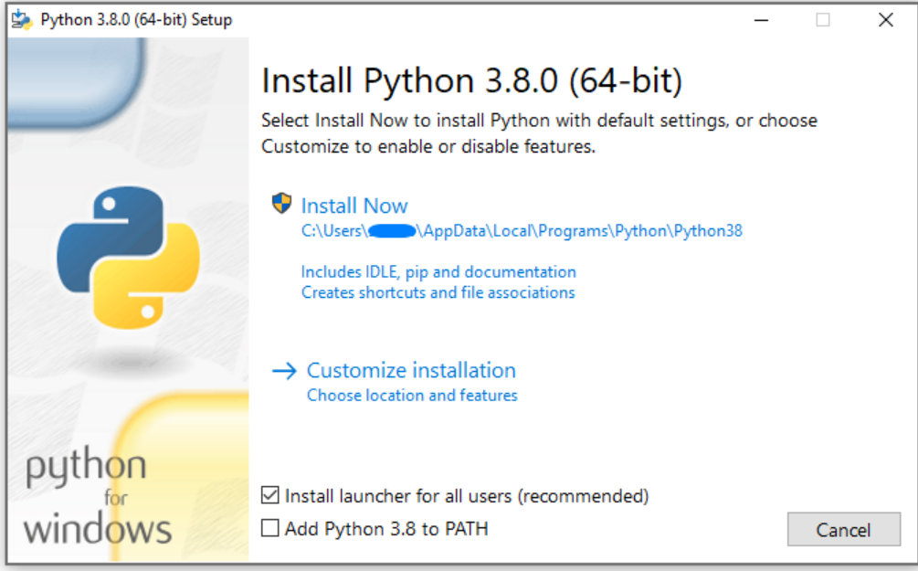

1. Install Git on windows
2. Open Command prompt, go to directory where you can fetch the repository.
3. pip install pymysql
4. pip install Flask
5. pip install flask-cors
6. pip install flask-mysql
7. git clone <https://github.com/shanti-sudo/technical-test>
8. cd technical-test
9. python3 -m venv dev
10. dev\Scripts\activate
11. python3 main.py
12. Run <http://127.0.0.1:5000/> on browser

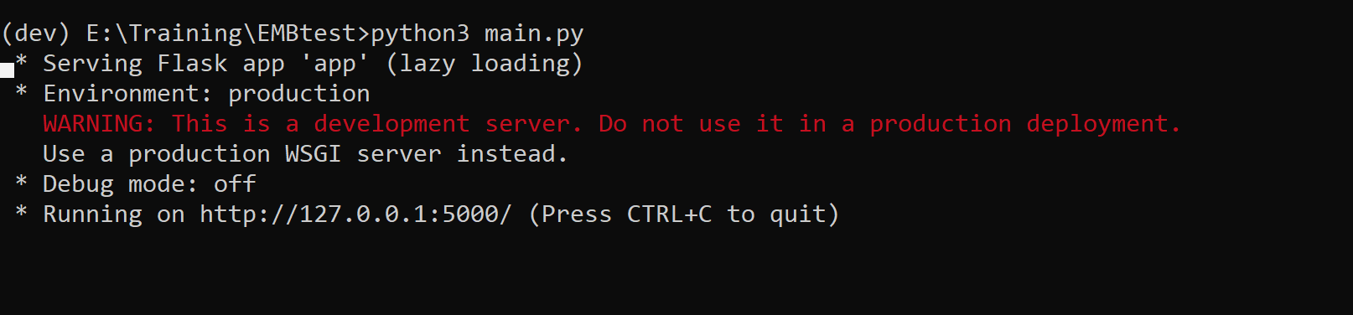

1. Try API form

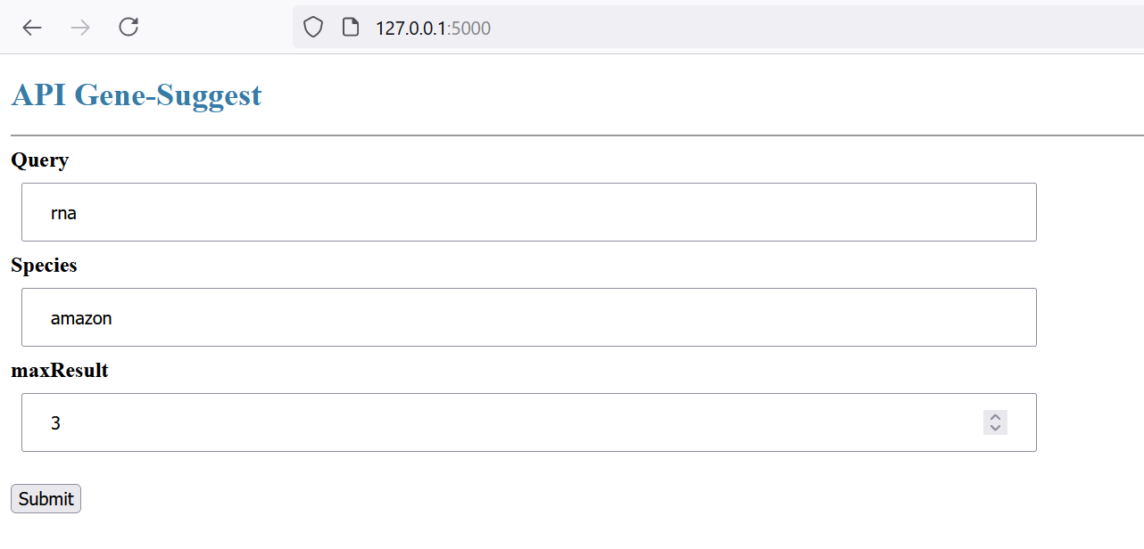

1. Output

